HMIS Portal
UI/UX & Functional Issues Log
hcare.craftcollect.africa
Prepared for: Kelvin Njuguna / Craft Silicon
Date: 17 September 2026
This document is a running log of issues and gaps identified while reviewing the HMIS portal. Each entry includes a brief description, a screenshot, and a reference link where a prototype exists. Items are ordered chronologically, following a patient's path through the system: the Admissions table, then the Admit Patient modal, then the patient's Kardex/chart screens.

Issue 1 — Add Order (Nursing Activity)
Module
Kardex → Add Order (Nursing Activity) modal, Enter Details step (Laboratory Details)
Description
On the Enter Details step, field spacing is cramped, and the Lab Test search field (min 2 letters) returns no results — a nurse cannot search for or select a test. The Radiology Details step’s equivalent field has the same defect.
Steps to Reproduce
- Open a patient's Kardex tab.
- Click “+ Add Order”, select order type “Laboratory”.
- On the Enter Details step, type 2+ letters into the Lab Test field.
- Observe: no results appear, and the step's fields feel visually cramped.
Status: Reproduced twice — once from a shared screenshot, once confirmed live on the production system. Not yet fixed.
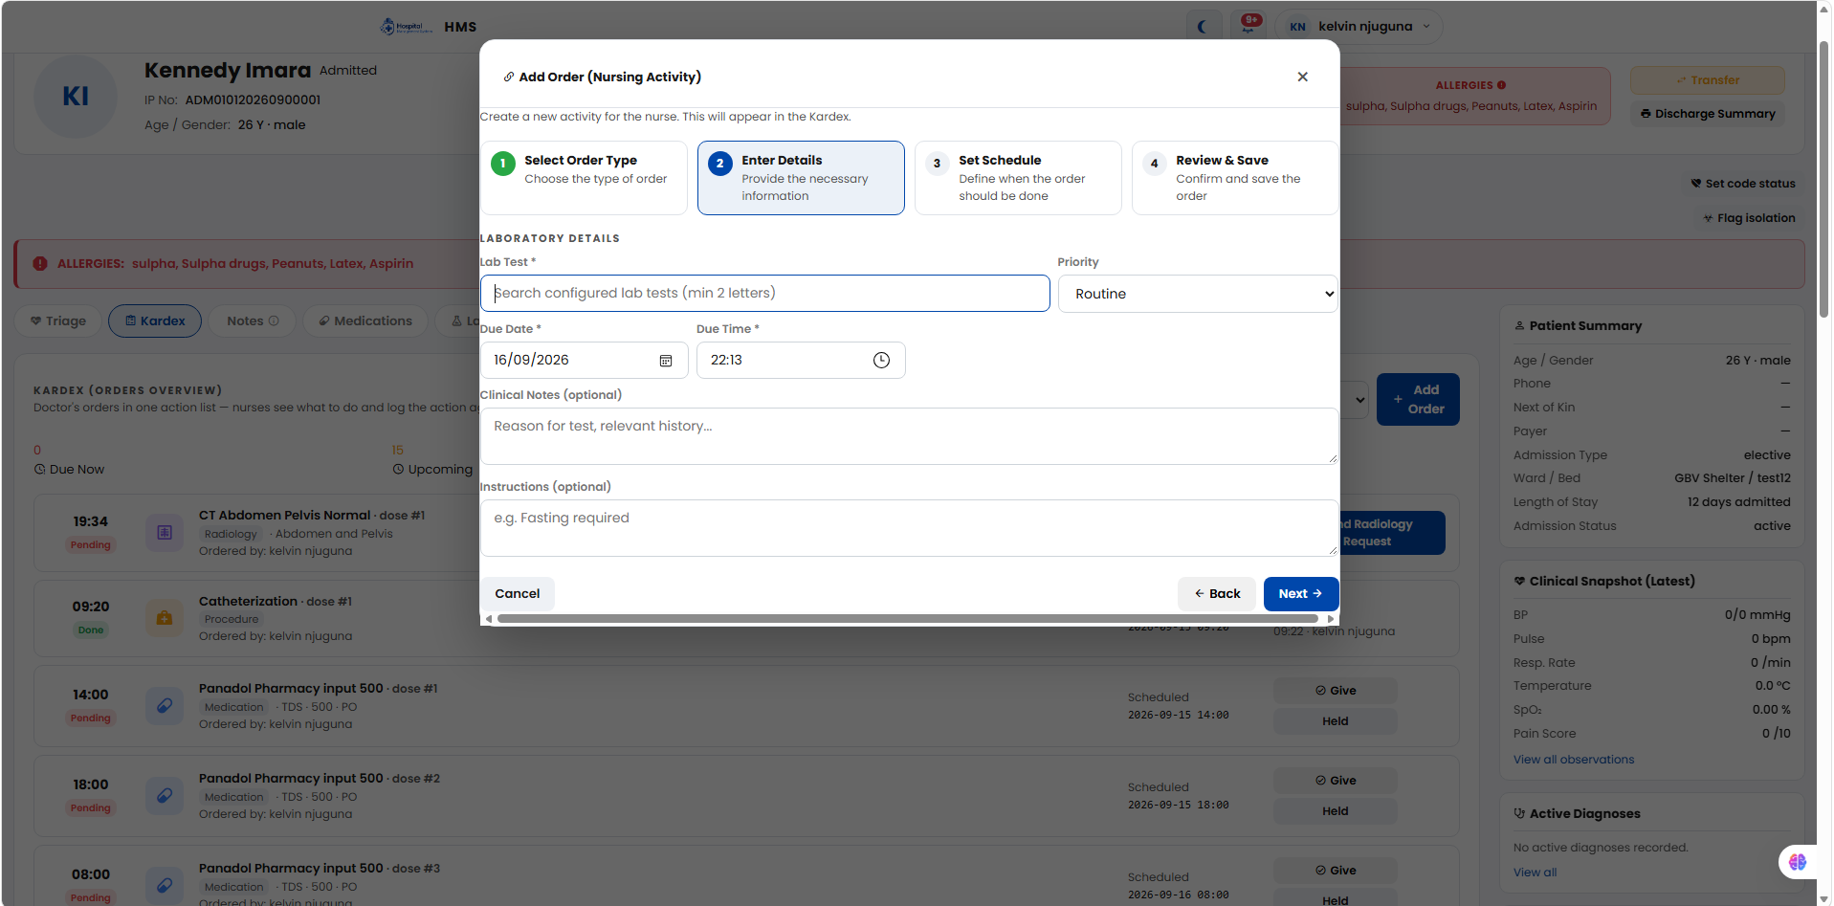
Add Order modal — Laboratory Details step, as first reported.
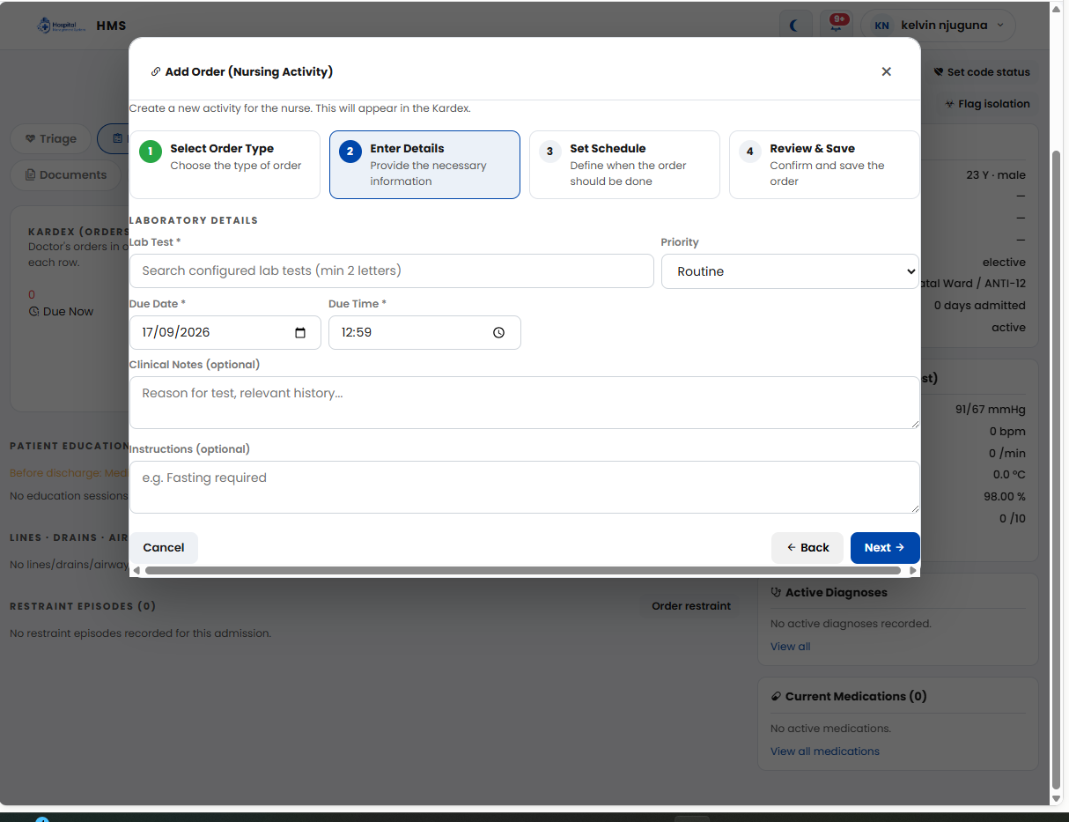
Same issue reconfirmed live on hcare.craftcollect.africa.

Issue 2 — Kardex (Current Medications Panel)
Module
Kardex — right-hand “Current Medications” summary panel
Description
The panel pulls directly from the Kardex schedule, so it repeats each individual scheduled dose (e.g. “Panadol 500mg” shown five times) instead of listing each unique drug once.
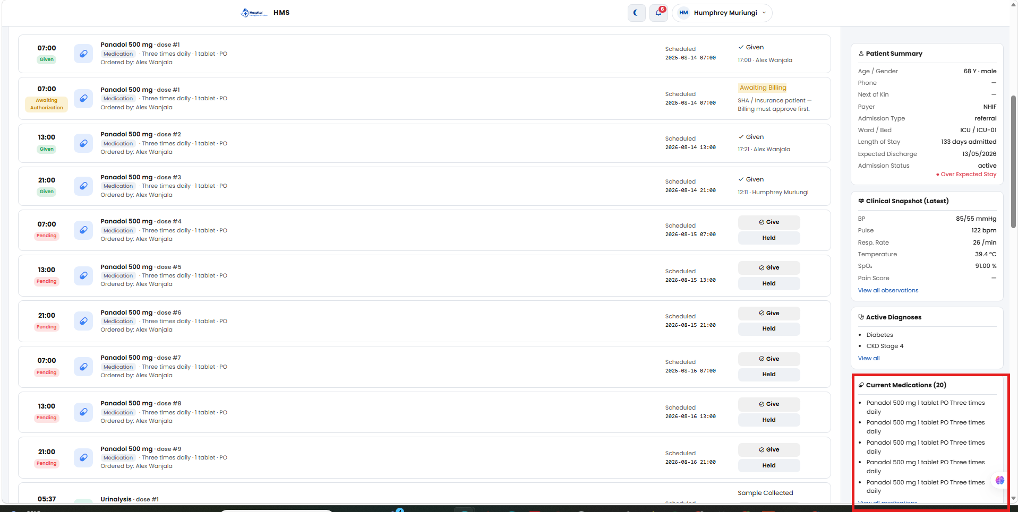
Current Medications panel — same drug listed repeatedly instead of a unique list.

Issue 3 — Patient Record Header
Module
Patient record header (Kardex and other tabs)
Description
The “Consultant” and “Primary Diagnosis” fields show blank (“—”) even for long-admitted patients — observed on a patient 133 days into an ICU admission, and reconfirmed on a same-day admission.
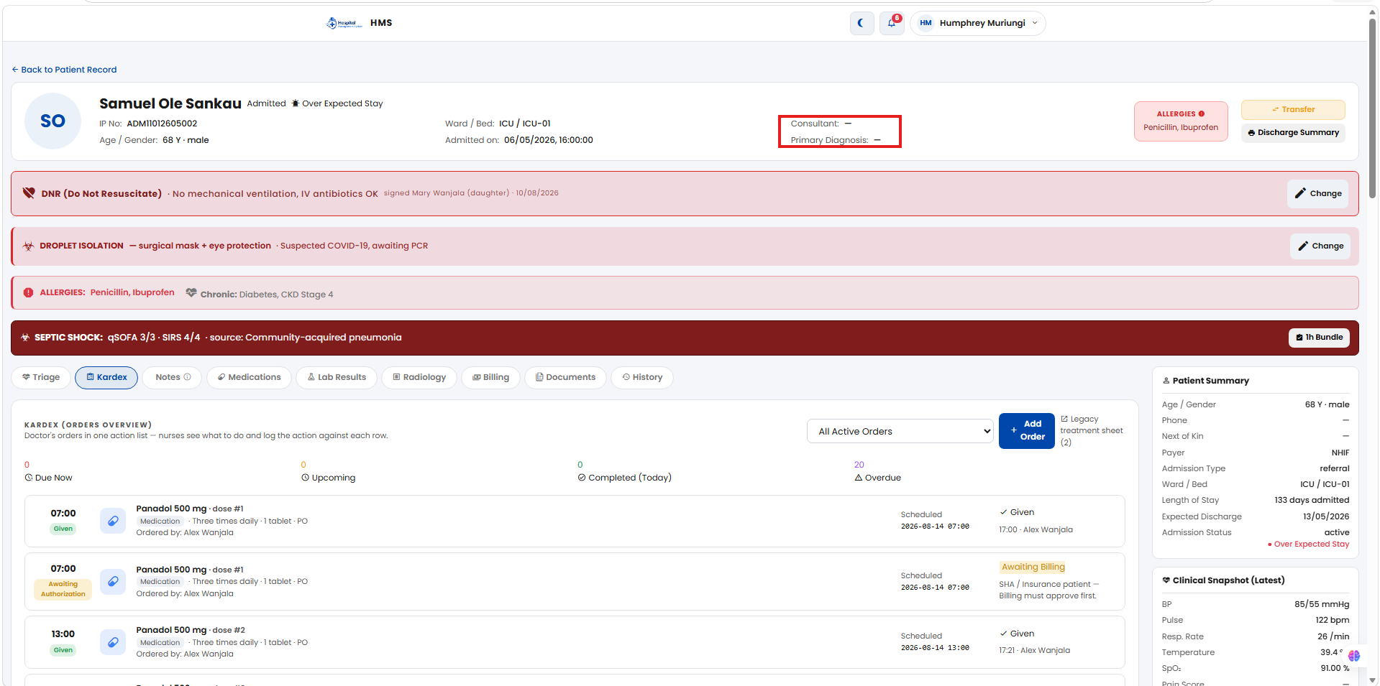
Consultant and Primary Diagnosis both blank on an active ICU admission.

Issue 4 — Lab Results / Radiology / Procedure Tabs
Module
Inpatient record — Lab Results, Radiology, and Procedure tabs
Description
These tabs show no history of their own — the Lab Results tab, for example, just displays a redirect note instead of the patient’s actual lab history.
Status: Confirmed live (UAT); not yet built.

Issue 5 — Medications Tab
Module
Medications tab
Description
There is currently no way to stop or discontinue a specific medication the patient is on from this tab.
Status: Requested feature; not yet built.

Issue 6 — Documents Tab
Module
Documents tab
Description
The tab’s own header text says “Consent forms, discharge summaries, and other patient documents,” but it only auto-lists the system-generated Discharge Summary — there is no upload/attach button.
Status: Confirmed live (UAT); not yet built.

Issue 7 — Mark Done Modal (Kardex Procedures)
Module
Kardex → Mark Done modal (e.g. “Mark done · dialysis”)
Description
- No field to record which staff member(s) actually performed/administered the procedure — the modal only has Date, Time, optional Clinical Notes, and an “Approved By” consent section (Not required / Patient / Next of Kin).
- The “Approved By” consent section correctly lets either the Patient or Next of Kin consent, but has no separate Witness field alongside that choice.
- Design review of the prototype for this consent section found a gap: selecting Patient, or filling in Next-of-Kin details, immediately shows a “Verified” badge — with no actual verification step (signature, OTP, confirmation checkbox) behind it.
Status: The prototype now includes a Personnel Involved section (Performed By + additional staff), resolving part of this issue. A separate Witness field and consent-verification step are still missing. Screenshot below predates this update.
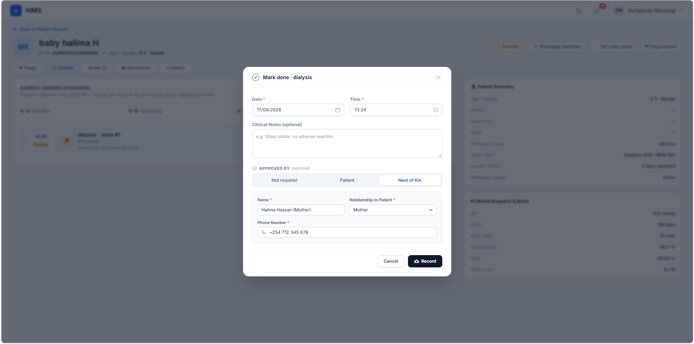
Live “Mark done · dialysis” modal — Next of Kin consent filled in; no Performed By or Witness field.
Prototype page (Approved By / Witness): https://ozzaynetwork.github.io/Craft-care-pages/approving-procedure.html

Issue 8 — Discharge Summary
Module
Kardex → Discharge Summary
Description
Today, Discharge Summary is a single flow with no disposition selector. Needed: five disposition types — Home/Routine, Referred Out, DAMA, Absconded, and Deceased — each with its own structured sub-form, plus a shared “Condition at Discharge” field.
Additional requirement: after discharge, allow creating a next/follow-up appointment directly from the workflow — capturing appointment date, department, and reason for the visit.
Status
Design prototyped and verified — each of the five disposition types shows its own dedicated sub-form. Sample printable discharge summaries were also produced for each disposition. Not yet built in the live app.
Prototype page: https://ozzaynetwork.github.io/Craft-care-pages/discharge-modal.html
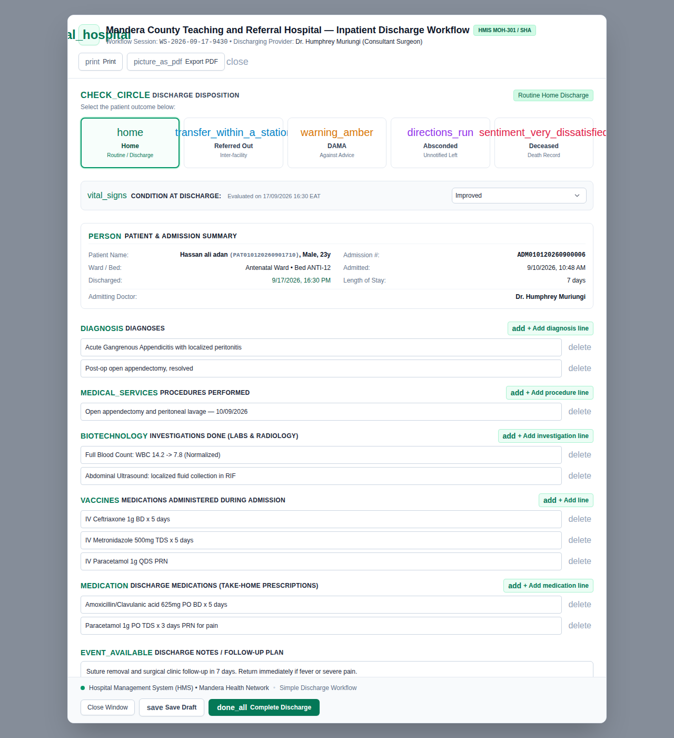
Discharge workflow prototype — disposition selector (Home / Referred Out / DAMA / Absconded / Deceased).
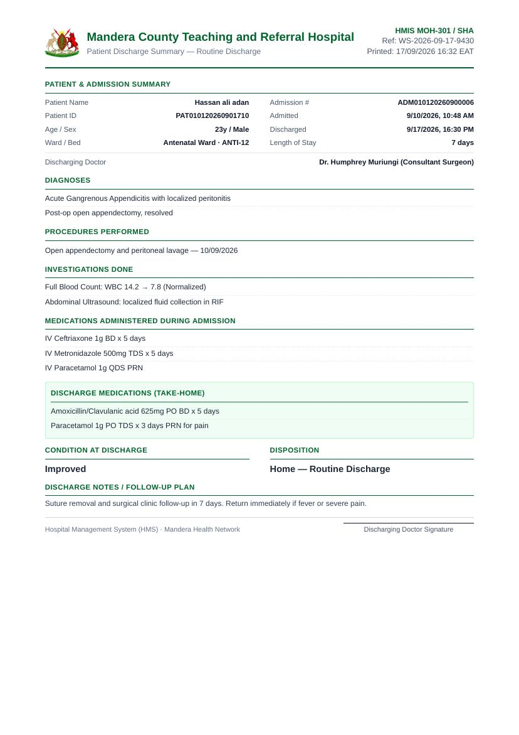
Sample printable discharge summary (Home/Routine disposition).

Issue 9 — Partograph / Labour Care Entry
Module
Maternity → Open Labour Record → Partograph tab → Add Entry
Description
- Supportive care is not captured at all — no fields for companion, pain relief, oral fluid, or maternal posture/position.
- Woman vitals capture Pulse, BP and Temperature, but not urine (protein/acetone), which the guide also tracks at each entry.
- FHR is a single number field — there is no field for deceleration type (early/late/variable).
- Medication is limited to Oxytocin (drops/min) — no field for other medicines given or IV fluids during labour.
- Notes is a single free-text box; the guide separates this into a structured Assessment and Plan, recorded with the mother as part of shared decision-making.
- No alert-range indication on vital fields (Pulse, BP, Temperature, FHR) — the guide defines safe-range thresholds that should flag automatically when crossed.
- Additional requirement: the Partograph should be reachable from two places — Maternity → Partograph, and the Inpatient Details tab above — both backed by the same underlying labour record, so an entry logged from either place updates the same data. At admission (Admit Patient modal, Issue 3), there should be a way to flag that the patient is in active labour and capture initial labour particulars, which attaches the labour record to that admission and activates the Partograph tab.
Status
Reviewed against the WHO Labour Care Guide (2020) and redesigned to close every gap above — FHR deceleration type, urine protein/acetone, other medicines/IV fluids, and a full Supportive Care section, each field showing its WHO safe range inline. Also redesigned as a dedicated “Partograph” tab within Inpatient Details (next to Triage), with dilation/FHR trend charts, an entries history table, a Labour Summary card, and a “Record Delivery” action. Prototyped and verified against the app's existing design system. Not yet built in the live app.
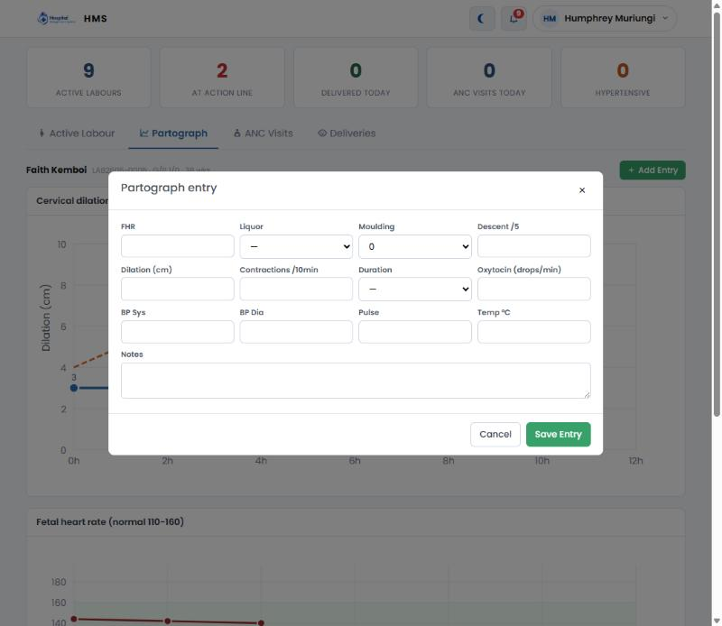
Current Partograph entry modal (Maternity → Open Labour Record) — captures FHR, liquor, moulding, descent, dilation, contractions, duration, oxytocin, BP, pulse and temperature only.
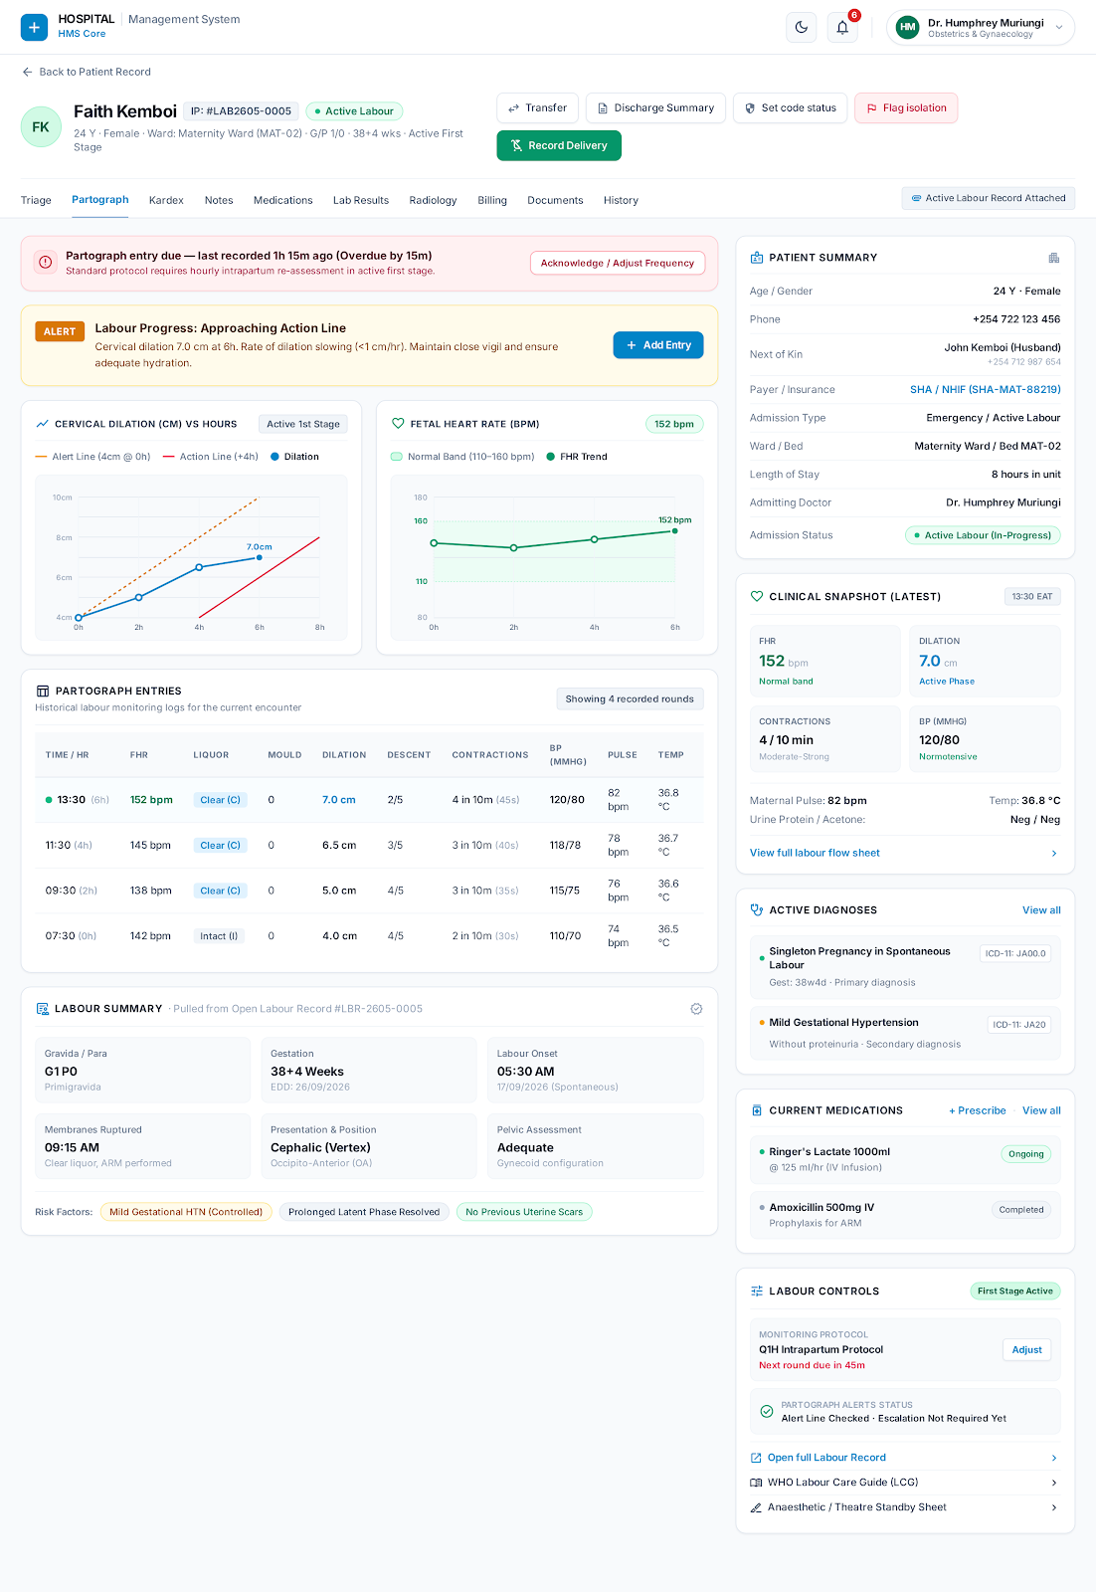
Redesigned Partograph tab — dedicated Inpatient Details tab (next to Triage) with alert banners, dilation/FHR trend charts, entry history, Labour Summary, and a Record Delivery action.
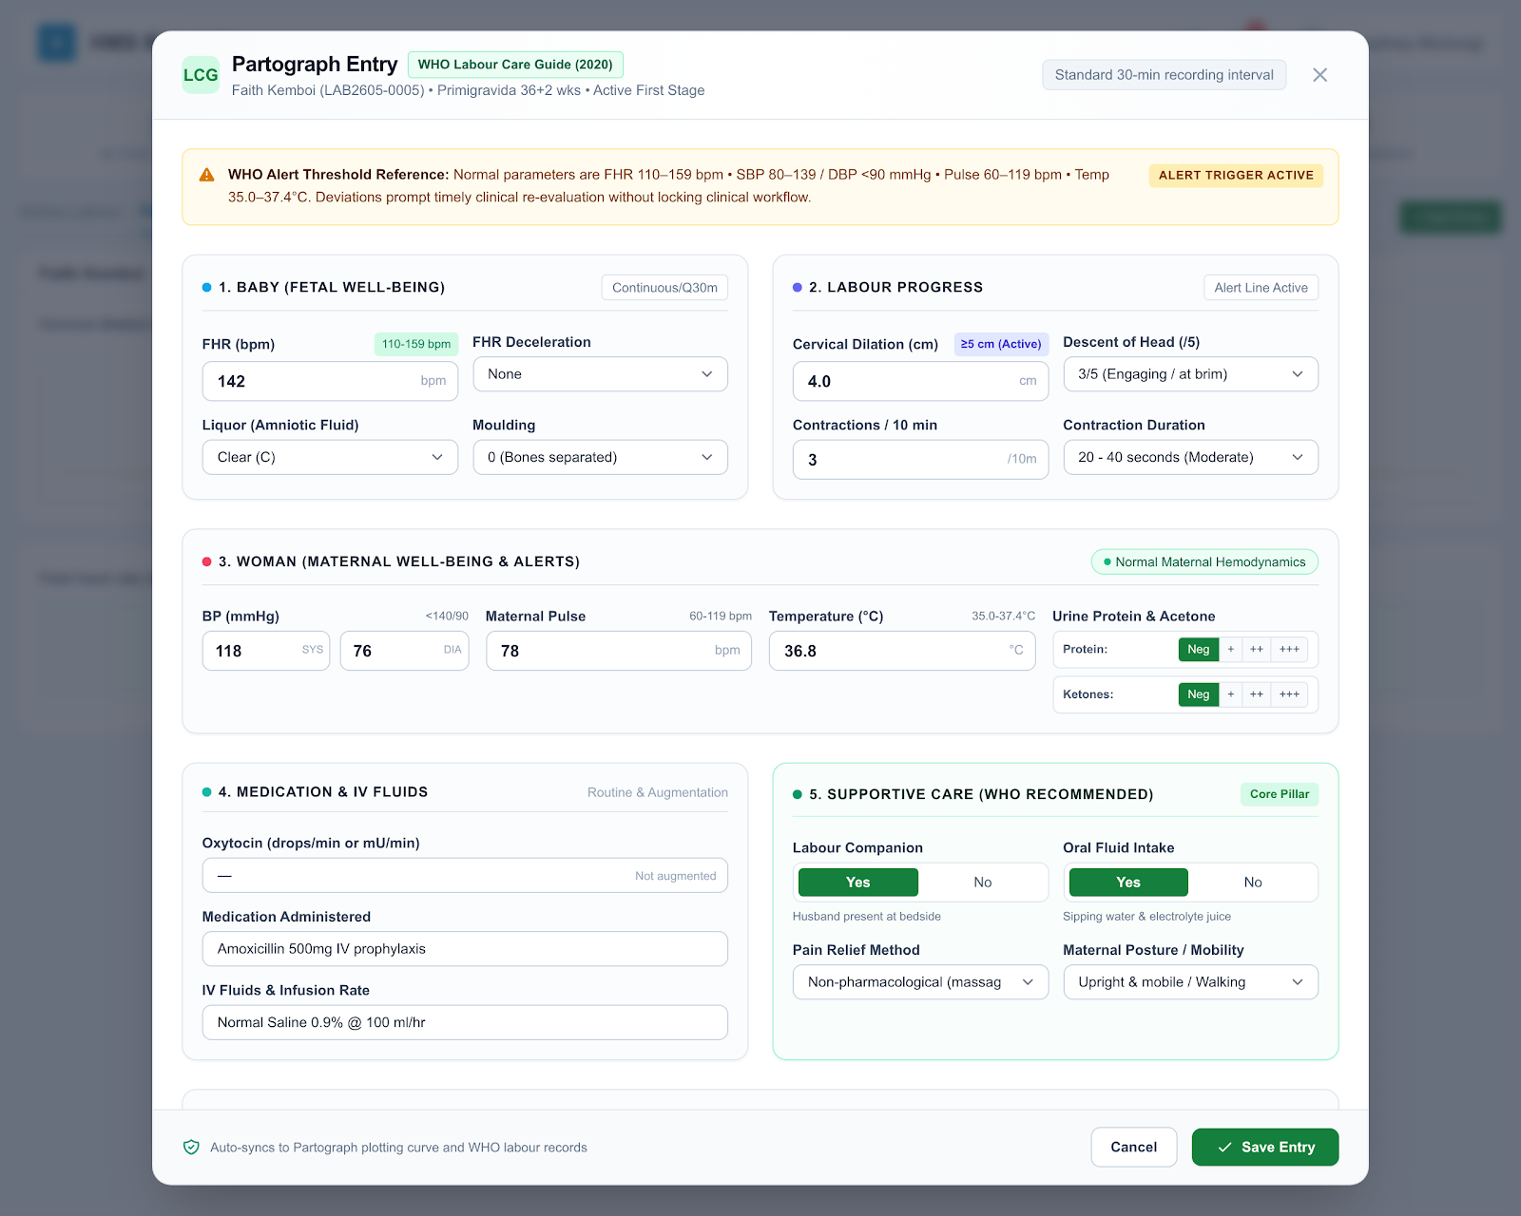
Redesigned Partograph Entry modal — covers every WHO Labour Care Guide field (deceleration type, urine protein/acetone, other medicines/IV fluids, Supportive Care), with WHO safe ranges shown inline.
Prototype page (Inpatient Partograph tab): https://ozzaynetwork.github.io/Craft-care-pages/inpatieont-patograph.html
Prototype page (Partograph Entry modal): https://ozzaynetwork.github.io/Craft-care-pages/pathograph-recording.html

Issue 10 — Cardex / Treatment Sheet
Module
Inpatient Details → Cardex / Treatment Sheet
Description
- Cardex and order administration were combined in a single screen — the same view let anyone add a new order and also act on it (Give/Held, Send Lab Request, Mark Done), with no separation between what was instructed and what was actually administered.
- Redesigned as two tabs: Treatment Sheet, where the doctor/clinical officer writes instructions (the “+ Add Order” control now lives here), and Cardex, where nurses continue to act on those instructions (Give/Held, Send Lab Request, Mark Done, View Details) as before.
- Each instruction on Treatment Sheet carries an activity trail showing who instructed it, and — once acted on from Cardex — who logged it, who requested it (for lab orders), and who it was submitted to, each with a timestamp.
- Medication courses spanning more than a day (e.g. a multi-day antibiotic) show a rollup on Treatment Sheet: day X of Y, doses given so far, and percentage complete.
- Tab order across the record now reads Triage, Partograph, Treatment Sheet, Cardex, Notes, Medications, Lab Results, Radiology, Billing, Documents, History, and “Kardex” has been relabelled “Cardex” throughout to match the terminology used locally.
Status
Treatment Sheet prototyped and cross-linked with the rest of the inpatient record (Triage, Partograph, Cardex). Cardex itself still needs the “+ Add Order” control removed to complete the separation — not yet done. Not yet built in the live app.
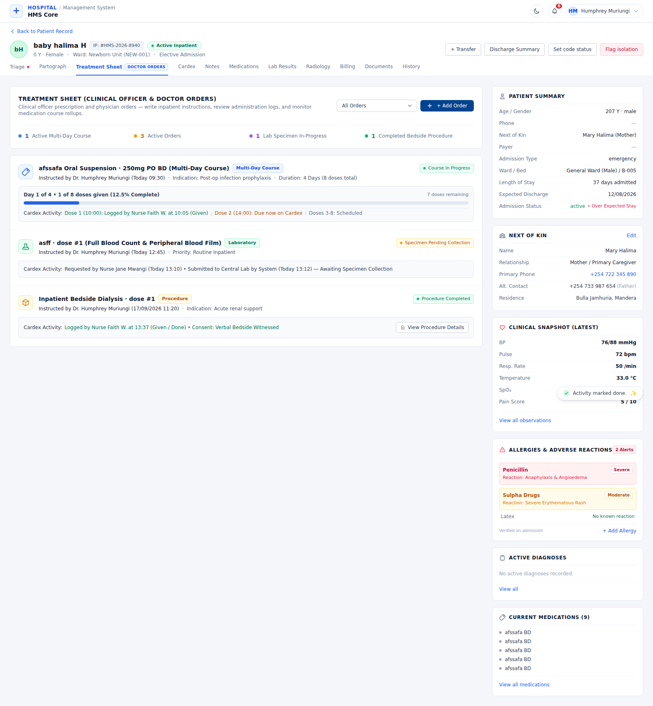
Treatment Sheet — new instruction/order tab, showing the multi-day medication progress rollup and per-order activity trail (who instructed, logged, requested, submitted).
Prototype page (Treatment Sheet): https://ozzaynetwork.github.io/Craft-care-pages/treatment-sheet.html

Issue 11 — Admissions Screen
Module
Admissions (Admissions Queue + Admitted Patients list)
Description
Three related gaps on the Admissions screen:
- The Referring Department column is blank for several patients in the queue — it should auto-populate from the department the staff member checked in under, rather than relying on manual entry.
- There is no search bar, making it hard to find a specific patient in a queue that can run 39+ entries deep.
- There is no filter to toggle between “awaiting ward/bed assignment” (the Admissions Queue table) and “already admitted” (the separate admitted-patients table below it) — distinct from the existing Active/Discharged/All tabs, which track discharge status, not bed-assignment status.
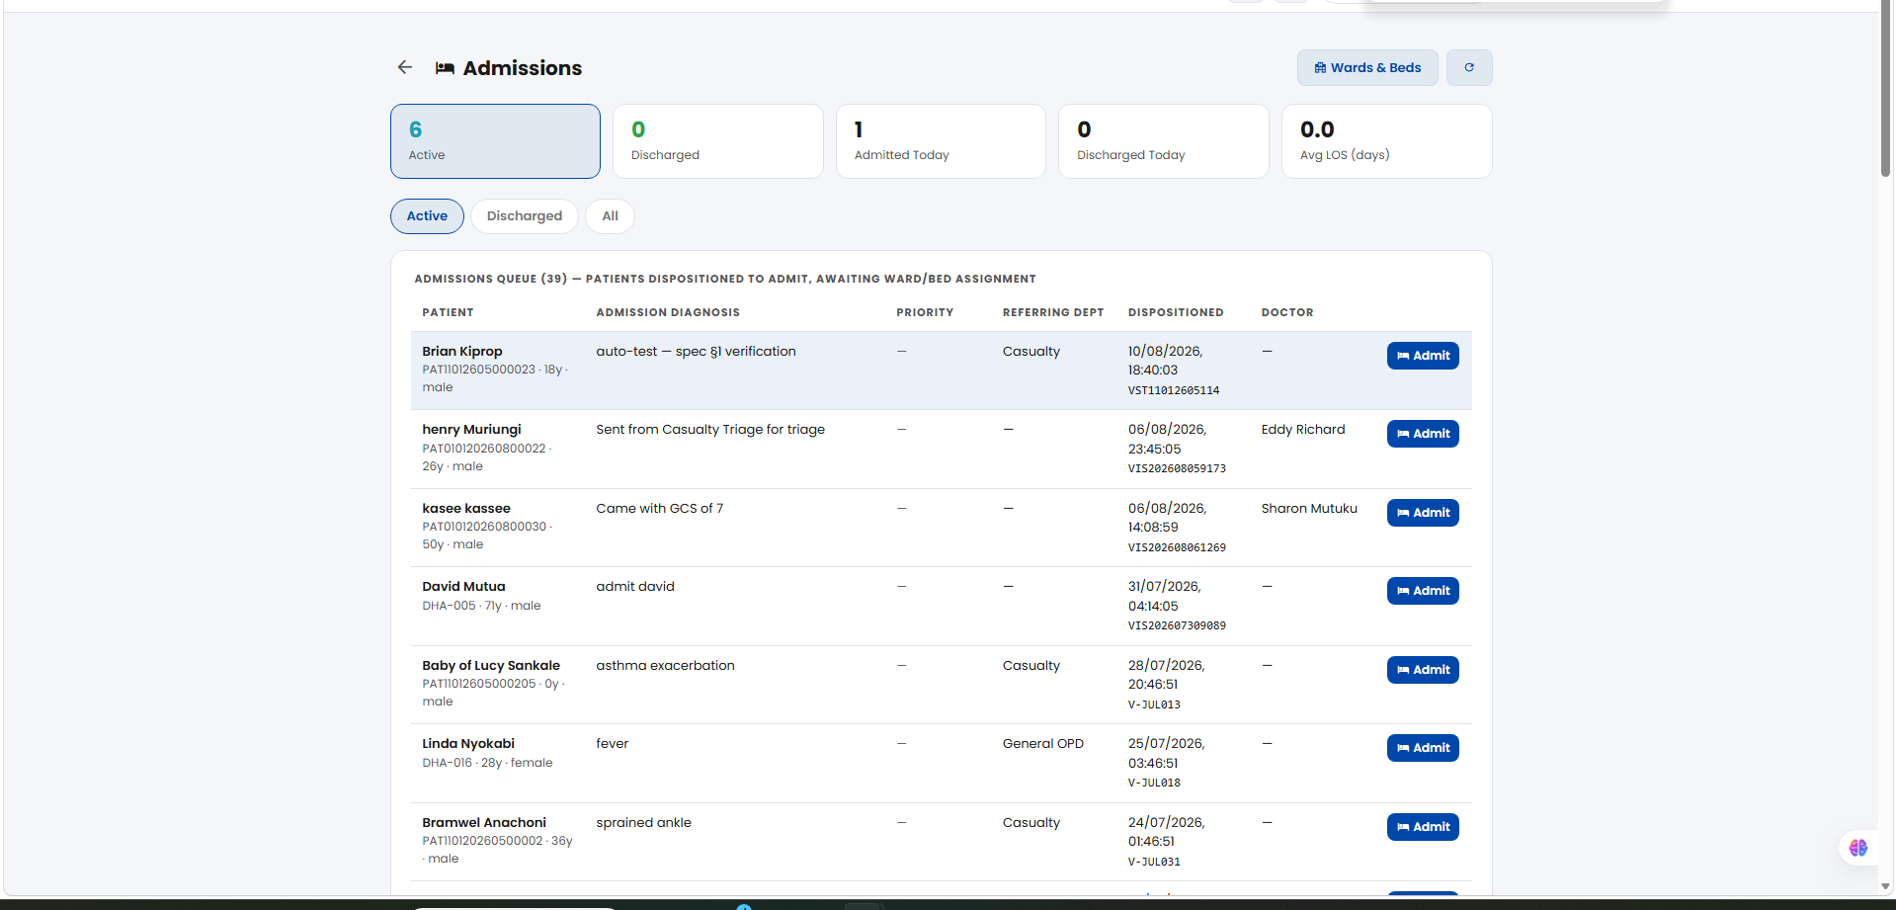
Admissions screen — Referring Department blank on several rows; no search or status filter.

Issue 12 — Wards & Beds (Active Admissions)
Module
Wards & Beds screen, Active Admissions tab — a second, separate path into admissions data alongside the main Admissions screen (Issue 11).
Description
This tab has the same missing-search gap as the main Admissions screen (Issue 11) — no way to search or filter the list, only scroll.
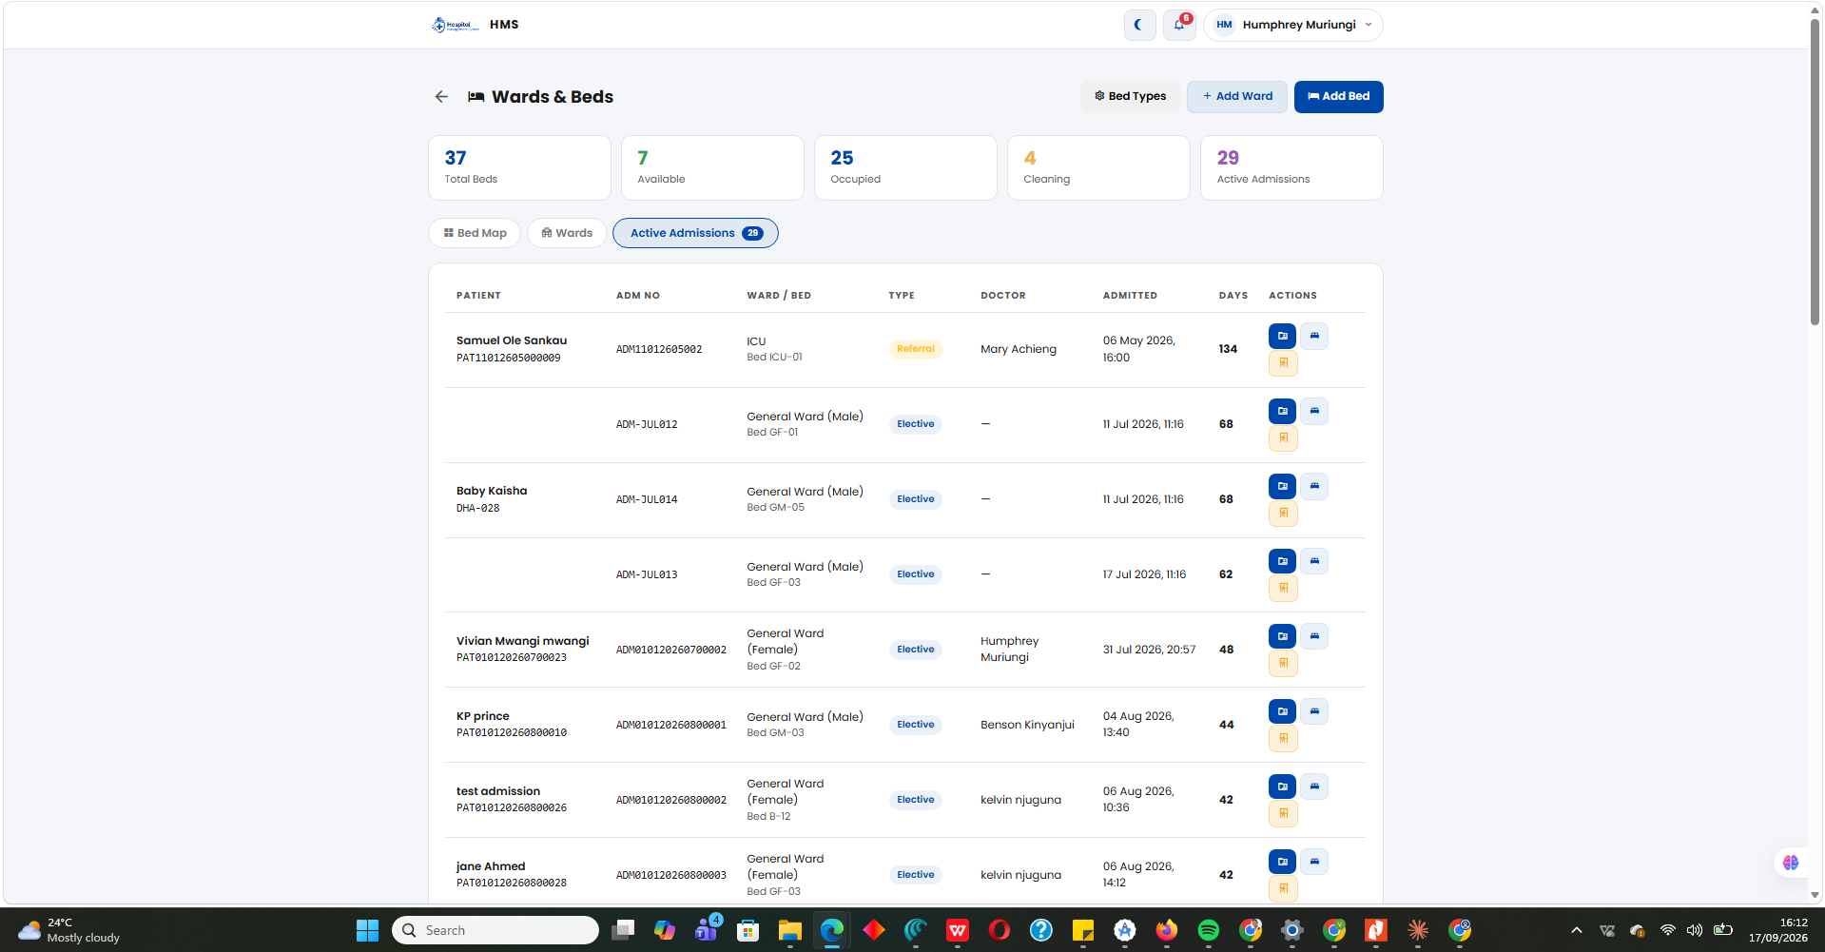
Wards & Beds → Active Admissions — no search bar.

Issue 13 — Admit Patient Modal
Module
Admit Patient modal (whole-form review)
Description
The Admit Patient modal is a single long scrolling form mixing billing, clinical-team, and diagnosis information — several fields are missing entirely:
- Payer Type (Cash / SHA / Private Insurer) — not captured at admission, even though it drives the entire billing path.
- SHA Beneficiary/Member Number — no field to record it, so claims can't be filed later.
- SHA Pre-Authorization Number — required by SHA for non-emergency admissions, not captured.
- Admitting/Consultant Doctor — not assigned at admission (this is the root cause of the Patient Record Header's blank Consultant field).
- Referring Facility / Referral Number — no way to record the referral chain for SHA's facility-level gatekeeping structure.
- Next of Kin / emergency contact — nowhere in the admission flow today.
- Clinical safety history — known allergies (not confirmed at admission, only shown later on the patient record if present), chronic illnesses/pre-existing conditions (e.g. diabetes, hypertension, CKD, asthma), seizure/fit history, and current home medications.
Status: A full 5-step Admit Patient redesign was built covering all fields above (Bed & Billing → Clinical & Diagnosis → Safety & History → Next of Kin → Notes & Confirm). Not yet built in the live app.
Note: the original “Admit for Observation” and “Don’t Queue” checkboxes aren’t visible in any of the 5 reviewed steps — worth confirming they weren’t dropped.
Prototype page: https://ozzaynetwork.github.io/Craft-care-pages/start-admission.html
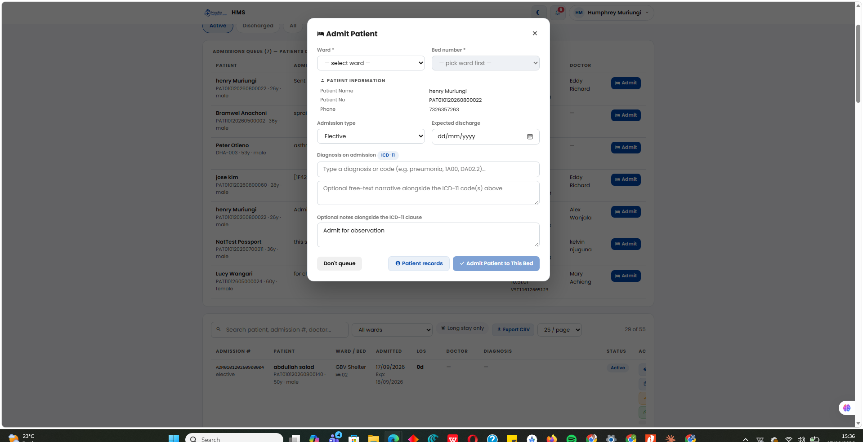
Before — Admit Patient modal with no Payer/SHA/Doctor/Referral fields.
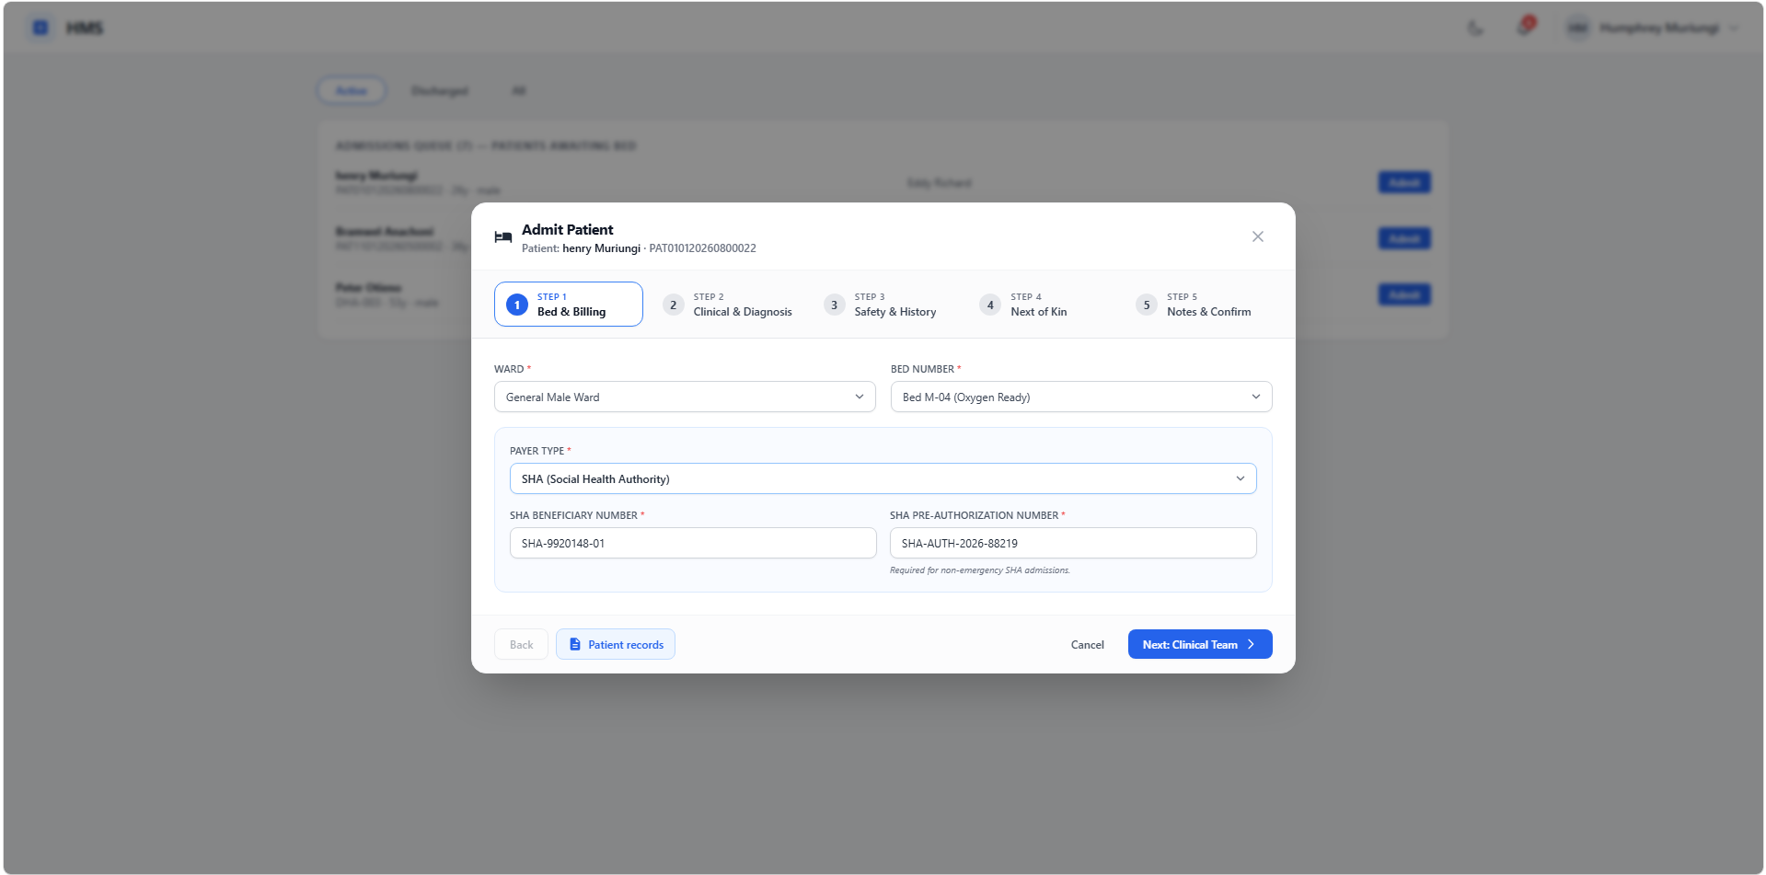
Step 1 — Bed & Billing (Payer Type, SHA fields).
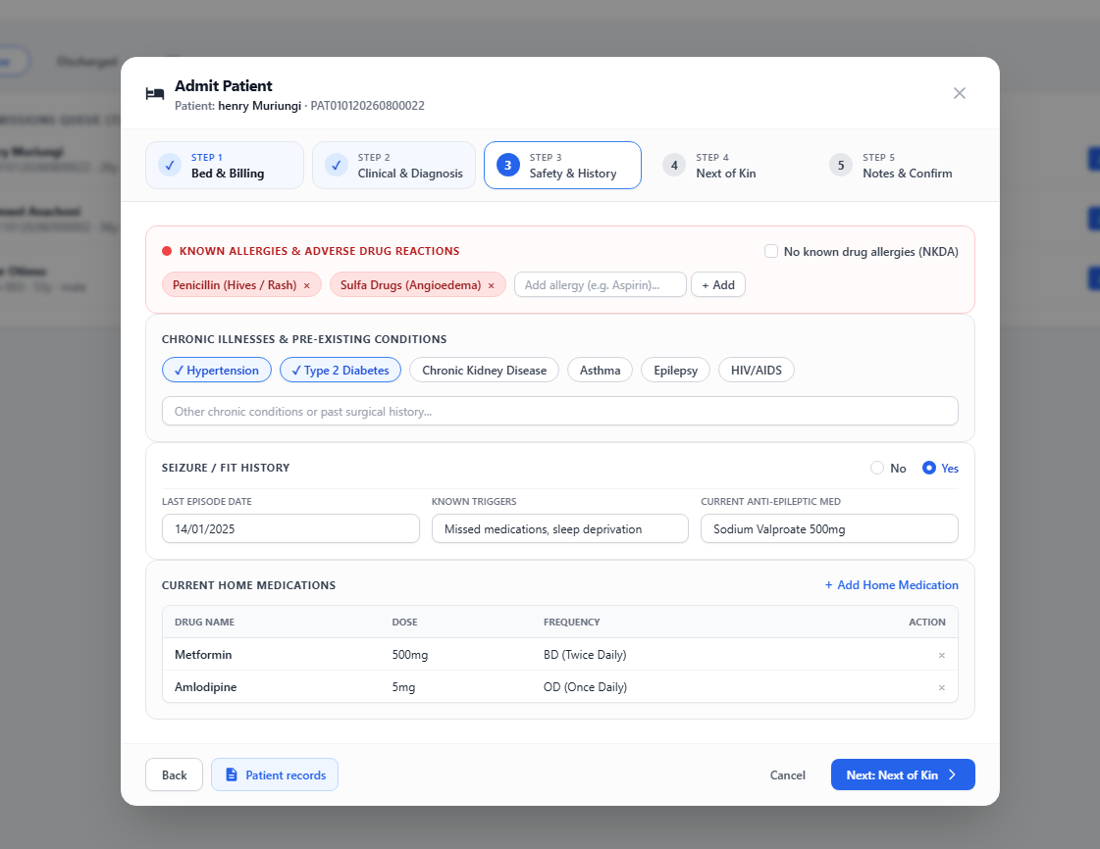
Step 3 — Safety & History: allergies, chronic conditions, seizure history, current home medications.
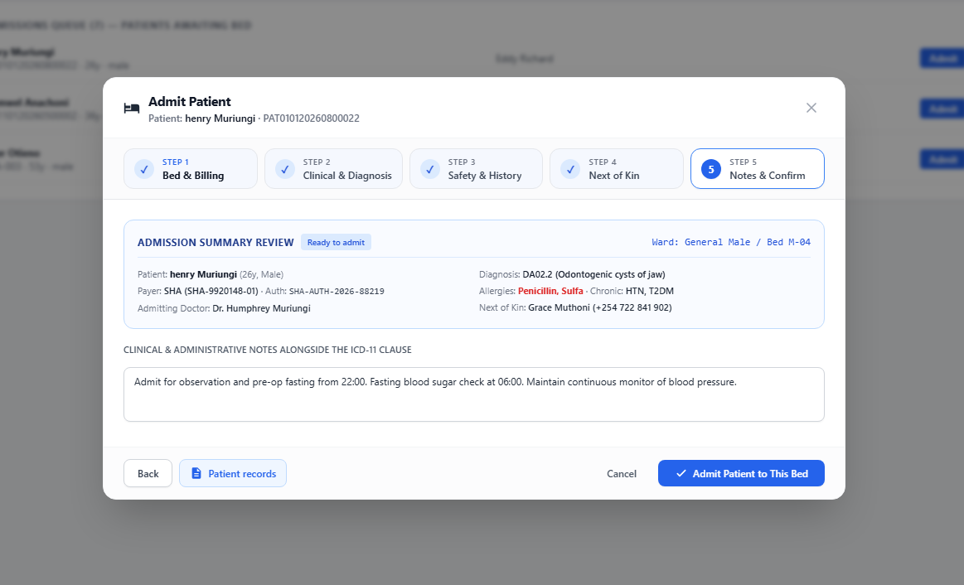
Step 5 — Notes & Confirm: full admission summary review before admitting.

Issue 14 — Pharmacy (Dispense Prescription)
Module
Pharmacy — Dispense Prescription modal
Description
When dispensing a prescription, there is no way to substitute a drug for an equivalent one if the pharmacy does not have the prescribed item in stock — the only stock-related control is a “Pick Stock” dropdown for the prescribed drug itself.
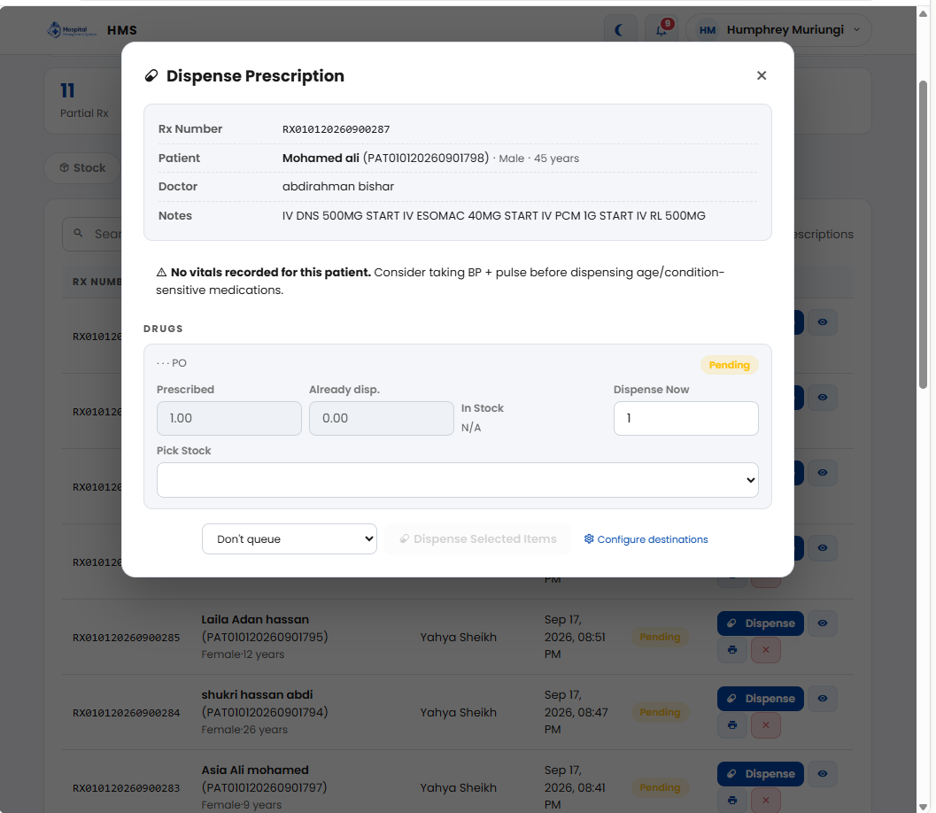
Dispense Prescription modal — no drug substitution option if the prescribed item is out of stock.

Issue 15 — Patient Search (Maternity & Programs Enrollment)
Module
Maternity → Open Labour Record (confirmed); Programs → Speciality Programs enrolment search — Diabetes, Cancer and Dialysis (confirmed, working correctly); Nutrition not yet tested.
Description
Live testing confirmed the Maternity search does not perform a real lookup: the Find action returns the same fixed patient (Hawa bulle) for any input, including a name that does not exist, and no new network request fires when Find is clicked. Diabetes, Cancer and Dialysis enrolment search were also tested live and found to search correctly — they do not share this defect.
Status
Confirmed live: Maternity's Open Labour Record patient search is not wired to a real search — it always shows the same fixed result regardless of query. Diabetes, Cancer and Dialysis enrolment search were tested live and work correctly. Nutrition enrolment search still to be tested.
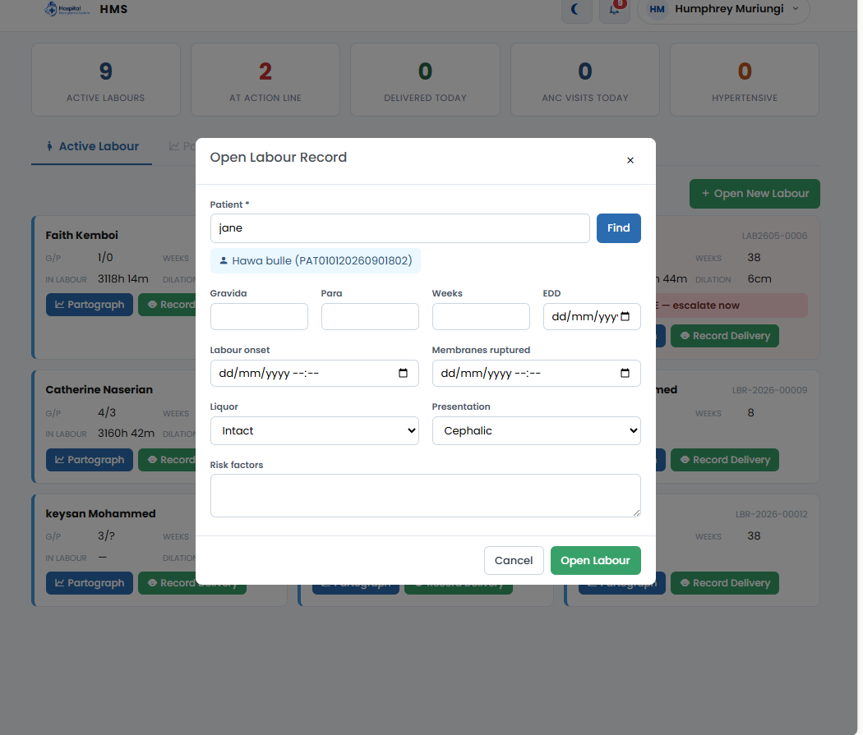
Open Labour Record — searching “jane” suggests an unrelated patient (Hawa bulle).

Appendix — Prototype / Reference Links
The discharge workflow and Kardex redesigns above are hosted as a clickable prototype for review — not the live app, a static HTML mockup:
https://ozzaynetwork.github.io/Craft-care-pages/
Individual pages:
- Inpatient home page — https://ozzaynetwork.github.io/Craft-care-pages/Inpatient-home-page.html
- Start admission (Admit Patient modal redesign) — https://ozzaynetwork.github.io/Craft-care-pages/start-admission.html
- Kardex — https://ozzaynetwork.github.io/Craft-care-pages/Kardex.html
- Discharge modal (disposition workflow) — https://ozzaynetwork.github.io/Craft-care-pages/discharge-modal.html
- Approving procedure (Mark Done / consent) — https://ozzaynetwork.github.io/Craft-care-pages/approving-procedure.html
- Done procedure details — https://ozzaynetwork.github.io/Craft-care-pages/done-procedure-details.html
- Partograph tab (Inpatient Details) — https://ozzaynetwork.github.io/Craft-care-pages/inpatieont-patograph.html
- Partograph Entry modal — https://ozzaynetwork.github.io/Craft-care-pages/pathograph-recording.html
- Treatment Sheet — https://ozzaynetwork.github.io/Craft-care-pages/treatment-sheet.html
Inpatient home page
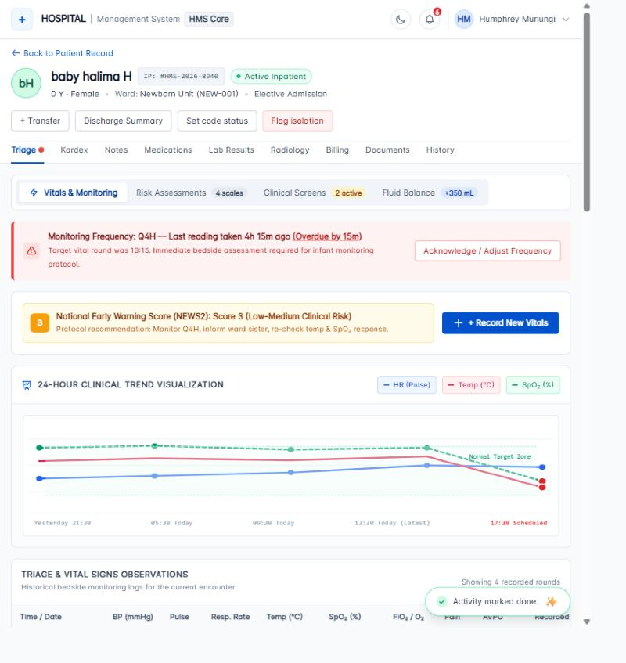
Inpatient home page — https://ozzaynetwork.github.io/Craft-care-pages/Inpatient-home-page.html

